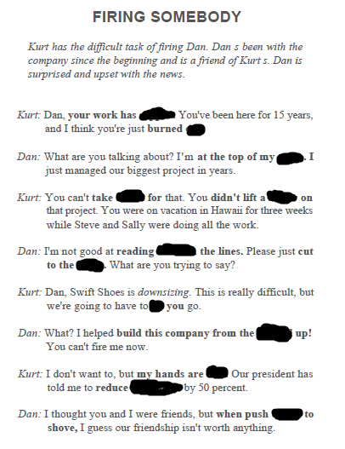

**comes, tight, headcount, let, chase, between, finger, game, slipped, out, ground, credit**

